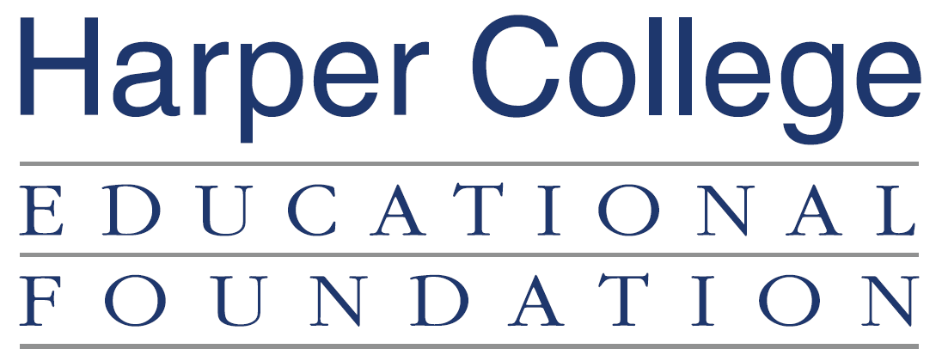

Donor Gift Form

Name(s): _________________________________________

Address: _________________________________________

_________________________________________

Cell Phone: ________________________

Email: ________________________

Gift Information

I would like to make a one-time gift in the amount of $__________________

___Enclosed is my check made payable to the Harper College Educational Foundation

___Credit Card Number: ______________________________ Exp. Date: ___________

Name on Card: ______________________________________________

Signature: __________________________________________________

Gift Designation

Please designate my gift to the Distinguished Alumni Scholarship Fund, which provides financial awards to students at Harper College.

I would like to restrict my donation to the following: _________________________________________

Matching Gift Information

My spouse or I work for a matching gift company: ______________________________________________
Company Name

Additional Information

I am interested in the following:

Establishing a Harper College endowed scholarship Including Harper College in my will or estate

Please return this form to
Harper Educational Foundation, 1200 West Algonquin Road, Palatine, Illinois 60067-7398.

Contact Shannon Hynes, shynes@harpercollege.edu or 847.925.6701, with questions.

