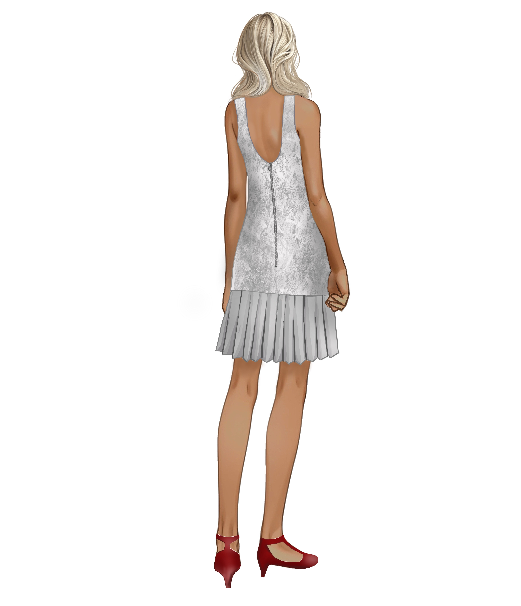
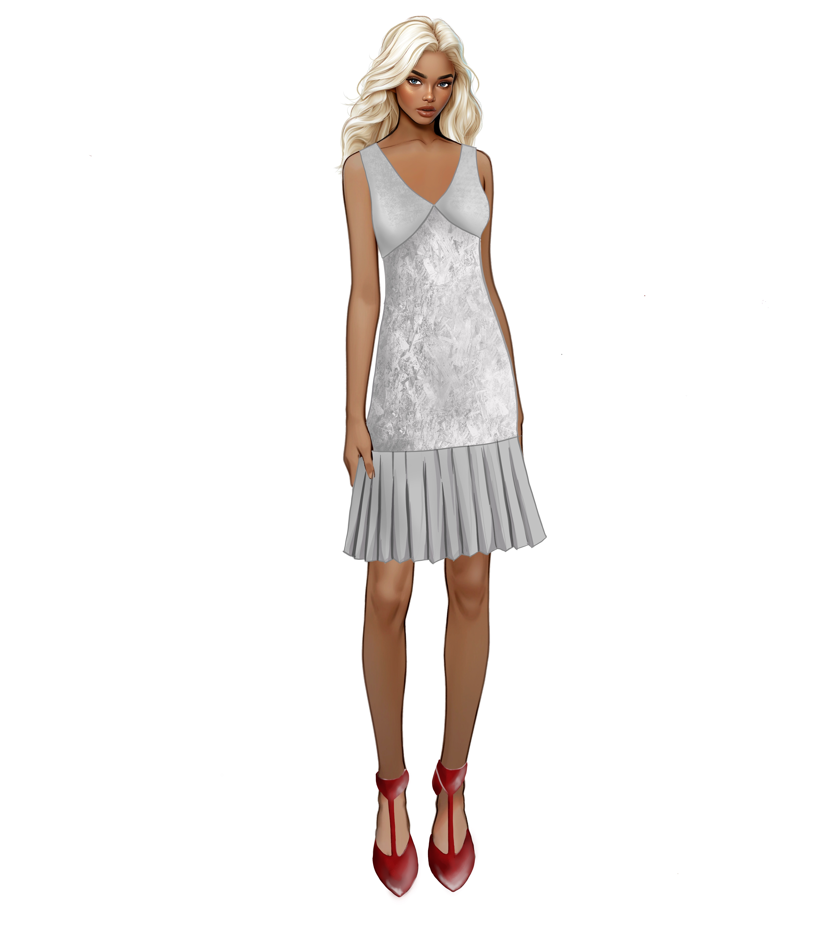
THE HARPER CHALLENGE 2025
Unleash your inner designer!

Passionate about Fashion Design?
Ready to transform your sewing skills into a stunning creation?
Looking for an exciting challenge?

This is your moment!
With the pattern provided, your creativity knows no bounds. Design your masterpiece and showcase it on the runaway at the Harper College Student Fashion Show. Embrace the future of fashion and let your creativity shine!

RULES:
- Eligibility: This competition is open to High School students 2024-2025.
- Theme: To align with this year’s Harper College Student Fashion Show theme “Cyberscape”, contestants are provided with a dress inspired by the famous 1920’s flapper dress. Contestants must submit a dress based on the provided design template and incorporate futuristic elements.
- Materials: Contestants must create the dress with fabric appropriate for the design. You may purchase notions such as thread, buttons and zippers. However, students must creatively construct and incorporate trims themselves. Eg: LED light-up hem
- Pattern instructions: Your garment must be true to the pattern and the instructions provided in the tech-pack. Design alterations are only allowed to the limit set forth in the tech pack.
- Model: Your garments may be designed for either yourself or your model. If you or your model are late or do not show up for the show you will be disqualified.
- Submission requirements: Place garment on a hanger that has a rotating hook in a see-thru, plastic, zippered garment bag. Complete the Garment Submission Form and staple it to the outside front of the garment bag (included in Tech Pack).
- Labeling: A sew-in muslin label (or similar) must be attached to the garment inside at the lower right hem with student name, school, instructor name, instructor email and instructor phone number. It should not be visible on the outside of the garment.
- Deadline: Garments must be dropped off at Harper College on Wednesday, April 30, 2025 in H255 from 3-5 pm OR Thursday, May 1, 2025 in H270 from 10 am- noon. No garments will be accepted after noon on May 1.

For more info contact:
Nupur Sharma  847.925.6788  nsharma1@harpercollege.edu | OR | Lucinda McDonald  847.925.6342  ml04156@harpercollege.edu

FASHION SHOW IS THURSDAY MAY 15, 2025, 7:00 pm
Fashion Show Theme: “CYBERSCAPE”

This year’s theme signifies a journey through time and imagination where past meets future with a spectacular blend of tradition and innovation. Participants will be provided with a design inspired by the iconic 1920s Flapper dress and are tasked with transforming this classic garment into a futuristic masterpiece.
Cyberspace unfolds in several ways:
- futuristic design with inspiration rooted in the past,
- traditional design techniques and classic materials are redefined and refreshed with new detail, color and pattern, demonstrating that our surroundings are forever evolving and shifting.
- technology and creativity merge for new innovation.
In the spirit of innovation, we invite participants to bring a modern twist to the Flapper inspired dress using futuristic materials. Use the theme to get inspired for your fabric and trim selection. Garments will be judged based on construction skills, creativity, adherence to the theme and overall impact.

(The theme should not be taken literally – the challenge is to interpret it as explained above or per the guidance of your teacher)

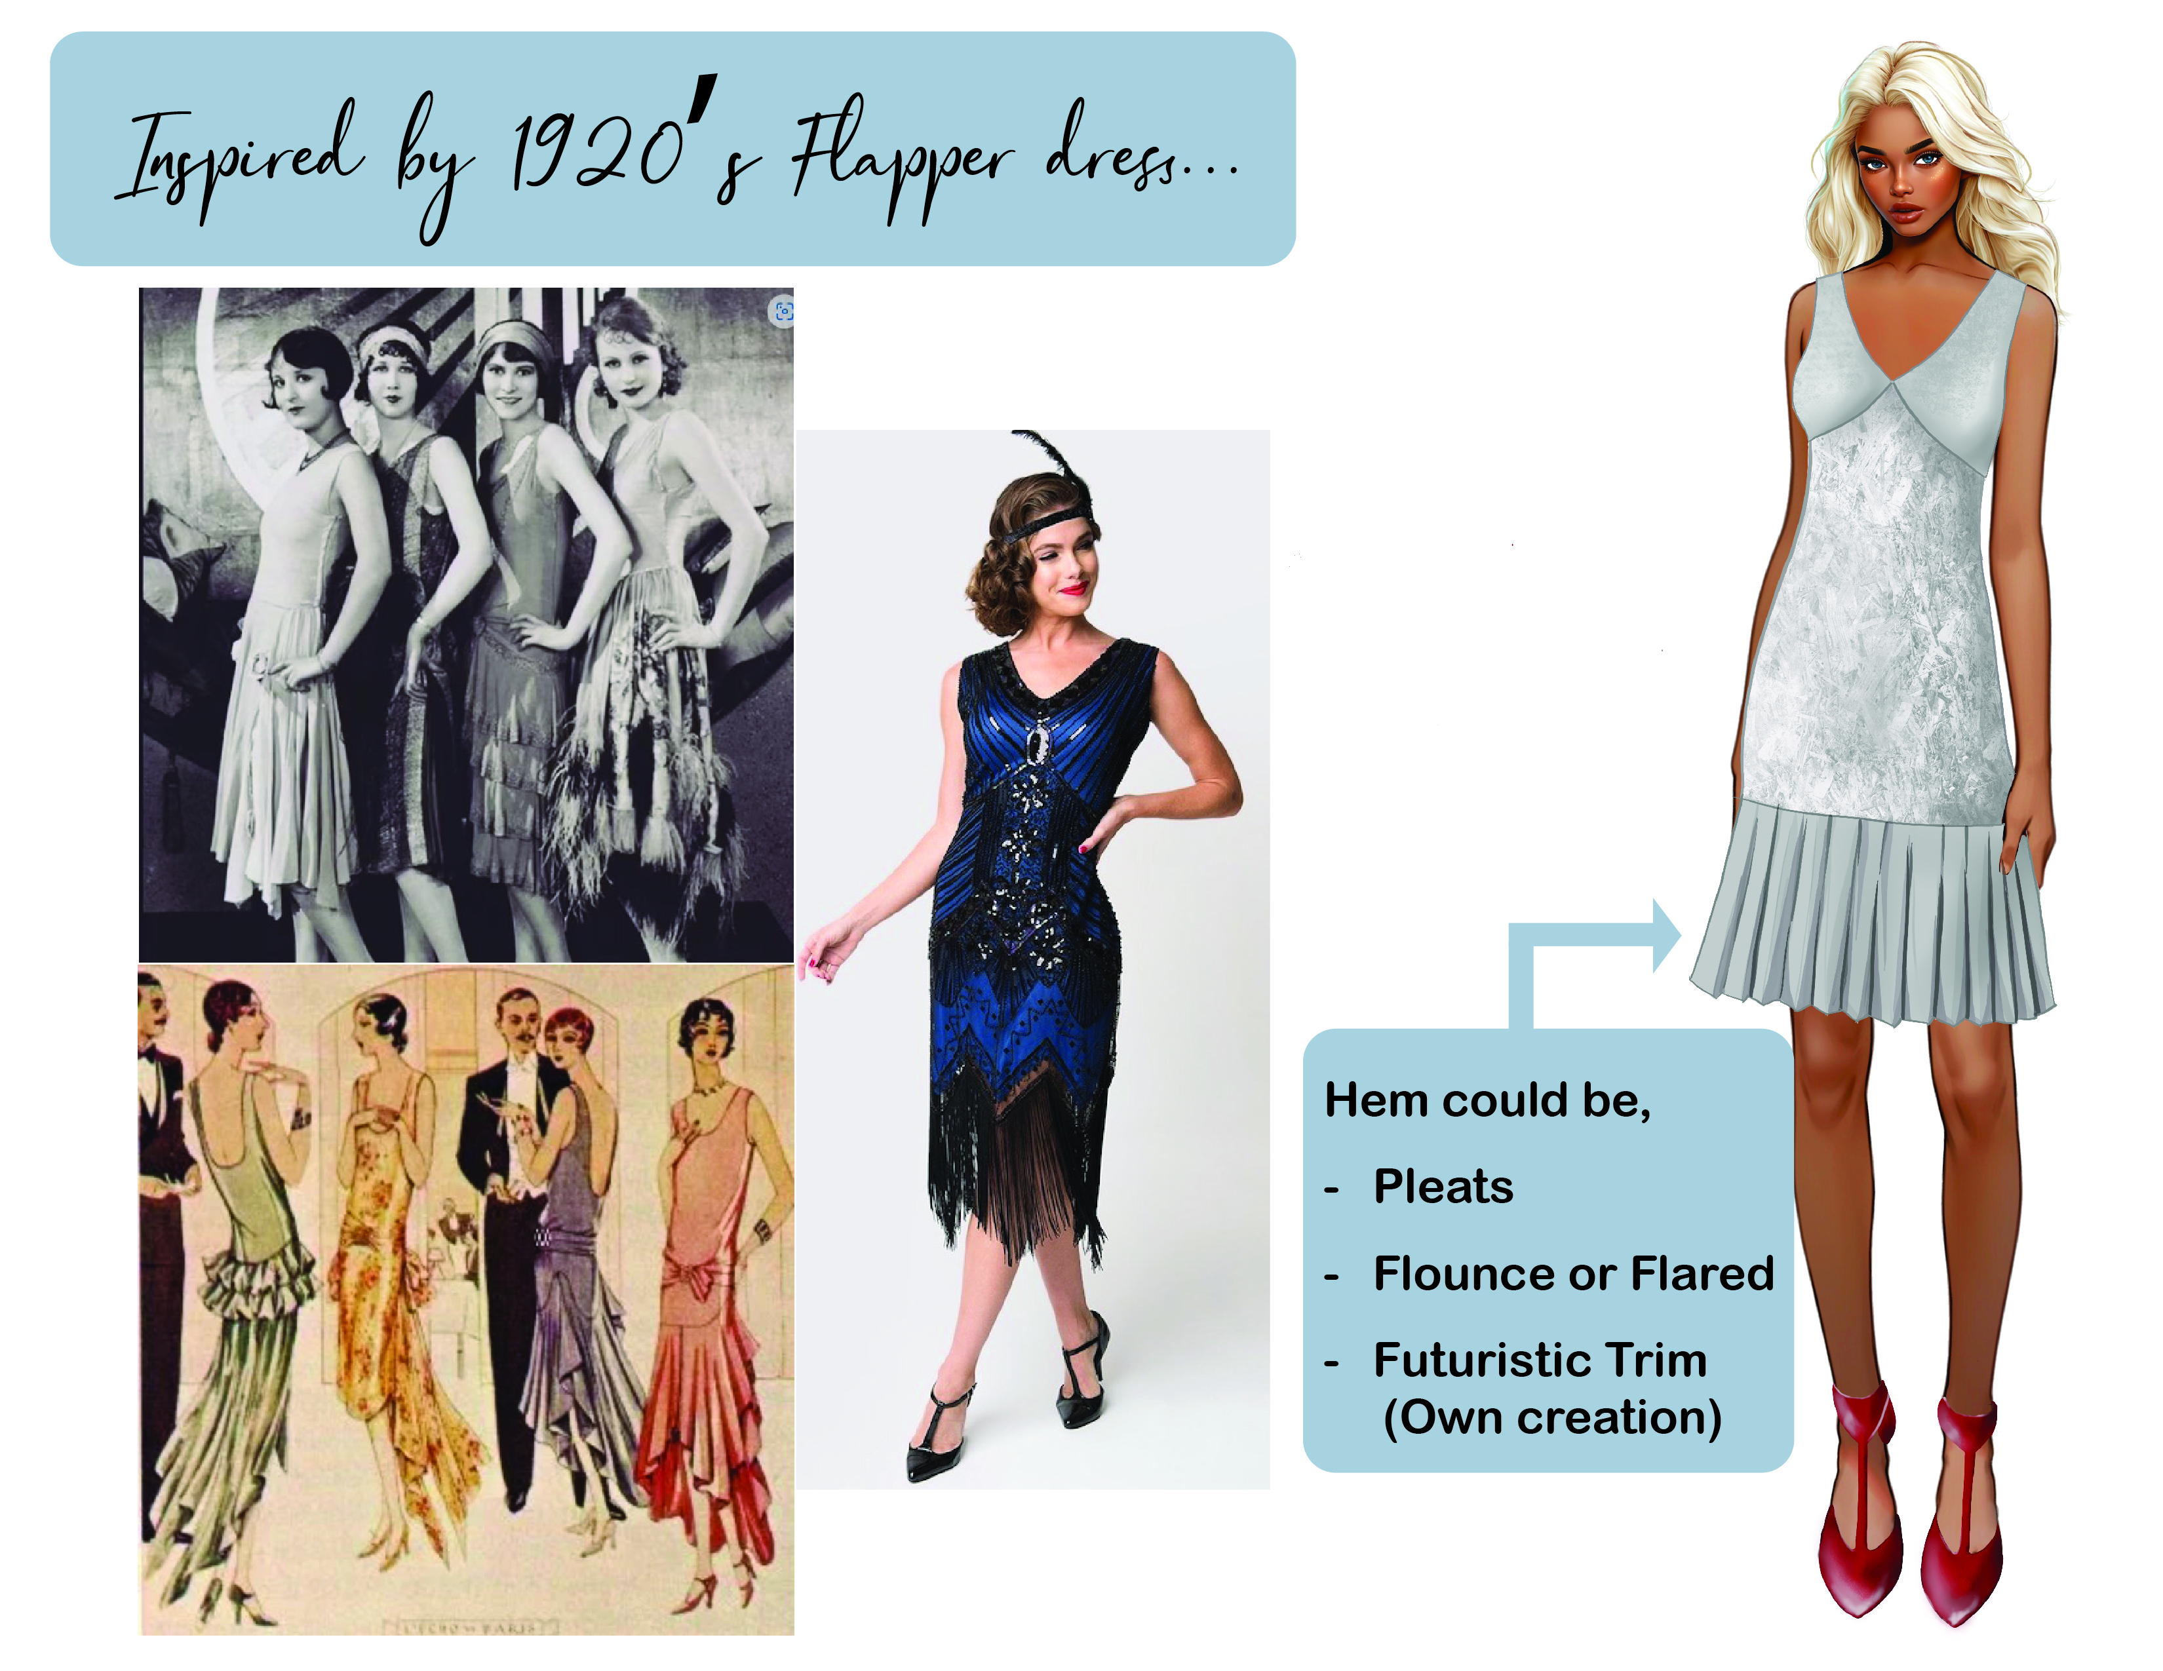
HOW WILL YOU CREATE THE FLAPPER INSPIRED DRESS FOR A WORLD OF TOMORROW?
Register and Pay Online at:
https://quikpayasp.com/harpercollege/commerce_manager/payer.do?orderType=The%20Harper%20Challenge
(If you have problems with the link, try cutting and pasting it into your browser.)
Fee is $15. Pattern and technical packet will be mailed to student care of their high school teacher. Teachers need to check their school mail slot and distribute to their students.

HARPER CHALLENGE 2025 AWARDS
Construction Awards
1st Place Construction Award $100.00
2nd Place Construction Award $ 50.00
3rd Place Construction Certificate
Judging is based on both the inside and outside of garments,
precision and quality of work and fit.

Creativity Awards
1st Place Creativity Award $100.00
2nd Place Creativity Award $ 50.00
3rd Place Creativity Certificate

Judging is based on the unique use of materials, adherence to the theme,
and appropriate use of the elements of design.

We request that a representative from each of the participating high schools be present at the show to receive awards.

